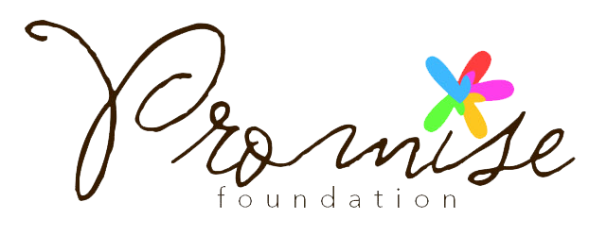
Offering young people a chance at a promising future

Mentor Registration Form

Please return completed application form to:
Hannah Benn Gordon, Promise Foundation, Queens Park Community School, Aylestone Avenue, NW6 7QB

Email: hannah@thepromisefoundation.org.uk

Title:

Full Name:

Address:

Postcode: Country:

Tel (Day): Tel (Eve): Tel (Mob): Email:

What do you hope to achieve by participating in this mentoring programme?

What are your professional interests?

By providing us with your email address and/or mobile telephone number you agree that we may contact you by electronic means.

Signed: ______________________________________________________________________ Date: ____/____/____

